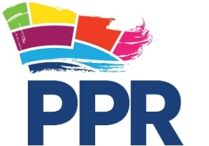
Participation and the Practice of Rights
Ground Floor, Community House
Citylink Business Park, 6a Albert Street
Belfast BT12 4HQ

Gift Aid Declaration Form

Gift Aid is a scheme that allows Participation and the Practice of Rights (PPR) to reclaim tax on every gift you make to us. So for every £1 you donate, we can claim back at least 25p from the government at no extra cost to you! All that is required is a simple, one-off *written declaration (*Please ensure you complete the form by hand if sending by post).

TITLE: |  | FORENAME: |  |  |  | SURNAME:
HOUSE NO:
ADDRESS LINE 1

TOWN

COUNTY |  |  |  |  |  | POSTCODE
TELE NO: |  |  |  |  | EMAIL:

Yes, I am a UK tax payer and I would like PPR to reclaim the tax on all qualifying donations that I have made, as well as any future donations until I notify them otherwise. (please tick)

Please remember that what you pay in income/ capital gains tax must at least equal the amount of tax that all the charities and Community Amateur Sports Clubs you donate to will claim on your Gift Aid donations in the tax year in which they are received. Other taxes such as Council Tax and VAT do not count for this purpose. The charity will reclaim 25p of tax for every £1 that you donate.

Please return this completed from to:
Participation and the Practice of Rights Community House, Citylink Business Park, 6a Albert Street, Belfast BT12 4HQ


Notes:

Please remember that this declaration is enduring and that it is your responsibility to notify us of any changes in your tax status, including changes to your name or address.

You can cancel the declaration at any time by notifying us either by phone on 02890313315, by email to avril@pprproject.org or in writing to the address above.

For full details of the Gift Aid scheme please check online at www.hmrc.gov.uk/individuals

The Inez McCormack Fund is a designated Fund within PPR
PPR Registered as a Company Ltd by Guarantee in NI Registration No: NI062880
Charity number: NIC103673

